Mini-Activity 4
Title: Calavera drawings Grade levels : 10-12
Name: Nicole Arencibia Date: 10/9/14
Time: 45 minutes (3)
Theme concepts:
Transparency—being able to see what its underneath or inside an object; getting to know the components of something (ex: x-rays show what our bones look like underneath the skin). It also applies to the non-physical state. People, their actions, motives can also be transparent or obvious.
Aesthetics, Art criticism, art history:
Jose Guadalupe Ruiz Aguilar Posada was a Mexican printmaker and draughtsman who whose subject matter involved advertising art, religious images, books, posters, broad sheets, political cartoons and news illustrations. He created lithographs and illustrated drawings. At the time, the adult level of literacy in Mexico in 1910 was reported as 32%. The publisher Posada worked for, Vanegas Arroyo, needed someone who could create illustrations despite the viewer’s level of literacy. Posada was able to illustrate images of local folk heroes, sensationalize crimes in the area, and develop story lines. Through his images, he created a visual language for his audience. He was best known for his “costumed skeleton characters” or Calaveras in Spanish. They were used as a tool for political and social satire.
Art Production concept(s):
-Proportion and disproportion—disproportion creates emphasis on an object in relation to the rest of the composition OR emphasis on a certain body part
Teaching Strategies:
Introduction
Interdisciplinary
Questioning
Demonstration
Discussion—creating narrative in artwork; a visual language that is universal—how can you achieve this?

Creative & Critical Abilities, Behaviors
1) Students will determine how to draw the skeletal framework of a figure in a magazine based on how the body is positioned.
2) Students will refer to an anatomical handout to figure out which specific bones to draw on the figure.
3) Students will determine what areas of the figure’s clothing are the most important/interesting by leaving it in the drawing; they will not draw bones where they want to show parts of a shirt for example.
NJCCCS and CCSS Standards & Indicators (one visual arts and one non-standard)
Visual & performing Arts Standard: 1.4 Aesthetic Responses & Critique Methodologies All students will demonstrate and apply an understanding of arts philosophies, judgment, and analysis to works of art in dance, music, theatre, and visual art. Indicator 1.4.12.A.2: Speculate on the artist’s intent, using discipline-specific arts terminology and citing embedded clues to substantiate the hypothesis.
Language Arts Standard: Standard 3.2 Writing: All students will write in clear, concise, organized language that varies in content and form for different audiences and purposes. 3.2.12 D. Writing Forms, Audiences, and Purposes (exploring a variety of forms): 7. Demonstrate personal style and voice effectively to support the purpose and engage the audience of a piece of writing.
Artmaking Steps:
1. Build on prior knowledge of language and what is, how it’s used, examples they know of.
2. Introduce how language can be used in a visual format, and how to develop a narrative through images.
3. Demonstrate how to use the materials, and how to achieve the finished product.
4. Students will find a large image of a posed person from a magazine.
5. They will use the vellum or tracing paper and tape it to the image. Students will trace the outline of the figure and other important details (clothing, hair, objects, etc.) that they want in their final drawing.
6. Refer to the anatomical handout and draw in the skeleton, based on how the figure is posed.
7. When done tracing, remove the vellum/tracing paper and outline with a black marker. Color in with markers or colored pencils (keep in mind how to create value with the placement of lines).
8. When drawings are done, tape to board backing or thicker paper to give it support.
9. Have students give their drawing to a partner. They will then make a narrative based off of what they see in the picture their peer has made.
10. They will trade back and discuss with each other. Pairs will share their discussion with the rest of the class.

Aesthetics Activity Steps/Questions:

Step 1: Put students into groups of 3-4. Give each group a copy of one of Pasada’s illustrations. They will also get a newspaper clipping that relates to the image, but is an unrecognizable language.

Step 2: Ask each group the following questions (which they will answer in their response journals): 1) What do you see in the image? 2) Can you tell what the article clipping says? 3) What does this image remind you of? Is there anywhere you can think of that it might be shown? 4) Describe the kinds of lines used in this image. Colors?

Step 3: Give students a short story to read about a folk hero. Ask them to draw a sketch that might visually explain what the story is about. Remind them to create a ‘visual narrative’.

Step 4: Ask the students to compare Pasada’s drawing to their own. Ask them the following questions: 1) How does your image relate to Pasada’s? How does it differ? 2) What did you do to add elements from the short story? 3) How do you think you created a visual narrative? 4) Do you think people who spoke any language could understand its meaning? 5) Do you think it is okay to leave some parts up for interpretation from the viewers?

Materials and Supplies:
“Simon el Bobito-Cuneto” and “Tale of Simple Simon” poems
Black markers
Anatomical handout of human skeletal system
Magazines with larger-sized images of people (sports or women’s magazines are good)
vellum or tracing paper
Board backing (to mount drawings on)
Colored markers or colored pencils
tape
http://www.moma.org/collection/artist.php?artist_id=4707 (information about Pasada)
Personal narrative worksheet

Rubric – Teacher Assessment of Individual Student Performance: “calaveras”
Teacher: Nicole Arencibia Date:____________ Period: _________ Grade: ________
 | 4 | 3 | 2 | 1 | Score
Met project criteria | Student finished project: created a calavera drawing by drawing the skeletal system, coloring and mounting work. | Student attempted to finish the calavera, but only drew a few areas of the skeletal system. They finished coloring most areas of the drawing, but mounted work. | Student did not finish the calavera drawing; there were barely any areas of the skeletal system drawn. There were only a few, small areas of color and the drawing was not mounted. | Student did not complete the calavera drawing. There were no skeletal system areas, there was no color used, and it was not mounted.
Craftsmanship | Excellent and extremely accurately drawn skeletal system. Great use of the coloring materials; very clean and careful usage. | Accurately drawn skeletal system. Good use of the coloring materials; clean and careful usage. | Decently drawn skeletal system. Okay use of the coloring materials; some colored strokes did not stay in their outlined area. | Poorly drawn skeletal system. Messy use of the coloring materials; the areas that were meant to stay white (the bones) had a lot of color on them.
Creativity | The calavera composition is highly original. Student went above just experimenting; they carefully made decisions from several possibilities. They clearly drew inspiration from Pasada. | The calavera composition is original. Student made an attempt to experiment; they made decisions with a little thought and drew made some references to Pasada. | The calavera composition is basic. Student made a slight attempt to experiment, but did not put much thought into decision-making. They did not reference Pasada. | The calavera composition lacks any creativity. Student made no attempt to experiment, and put no effort into decision-making.
Understanding | Student fully understood the purpose of the assignment, and how to develop a strong narrative in their work. | Student had good understanding of assignment, and how to develop narrative in their work. | Student had basic understanding of assignment, but had some trouble with developing a narrative in their work. | Student had no understanding of the assignment, or of developing any narrative in their work.

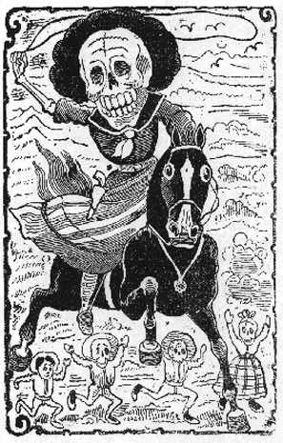
“Calavera Revolucionaria”, José Guadalupe Posada, Central panel of a larger sheet of images
which is 14" X 10 1/2" Print from broadside, circa 1910
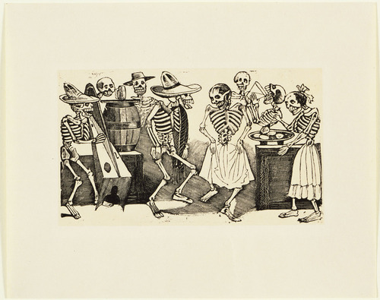
A Jig Beyond the Grave (El Jarabe en Ultratumba), Pasada, after 1888, relief engraving
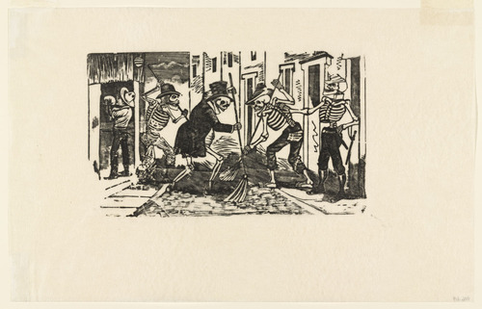
Street-cleaning Calavera (Calavera de los Patinadores), Pasada, n.d., reliefe engraving

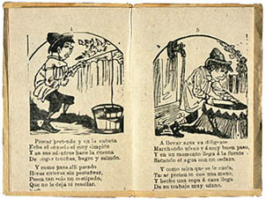
Simón el Bobito-Cuento (Tale of Simple Simon), Pasada, Pamphlet, engraving, 8 pages, inside
6" x 4"
“Simon el Bobito-cuento”—Rafael Pombo
Simón el bobito llamò al pastelero: "¡a ver los pasteles que los quiero probar!"
"Si –repuso el otro- pero antes quiero ver ese cuartillo con que has de pagar"
Buscó en los bolsillos el buen simoncito y dijo "!De veras!, no tengo ni unito".
A Simón el bobito le gusta el pescado y quiere volverse también pescador y pasa las horas sentado, sentado, pescando en el balde de mamá Leonor.
Hizo simoncito un pastel de nieve y a asar en las brasas hambriento lo echó, pero el pastelito se deshizo en breve, apagó las brasas, y nada comió.
Simón vió unos cardos cargando ciruelas y dijo: "!Qué bueno, las voy a coger¡", pero peor que agujas y puntas de espuelas le hicieron brincar, silvar y morder.
Se lavó con negro de embolar zapatos, porque su mamita no le dio jabón, y cuando cazaban ratones los gatos espantaba al gato gritando: "ratón"
Ordeñando un día la vaca pintada le apretó la cola en vez del pezón, y ¡aquí de la vaca¡, le dio tal patada, que como un trompito bailó don simón y cayó montado sobre la ternera, y doña ternera se enojó también, y ahí va otro brinco y otra pateadera y dos revolcadas en un santiamén
Se montó en un burro que halló en el mercado y a cazar venados alegre partió. Voló por las calles sin ver un venado, rodó por las piedras y el asno se huyó

Simple Simon
(1764)
Simple Simon met a pieman
Going to the fair:
Said Simple Simon to the pie man:
“Let me taste your ware.”
Said the pie-man to Simple Simon:
“Show me first your penny!”
Said Simple Simon to the pie-man:
“Indeed I have not any!”
He went to catch a dicky bird,
And thought he would not fail
Because he had a little salt
To put upon his tail.
He went to ride a spotted cow
That had a little calf;
She threw him down upon the ground,
Which made the people laugh.
Then Simple Simon went a-hunting
For to catch a hare;
He rode a goat about the street,
But could not find one there.
Simple Simon went to town
To buy a piece of meat;
He tied it to his horse’s tail
To keep it clean and sweet.
Simple Simon went a-fishing
For to catch a whale,
And all the water he had got
Was in his mother’s pail.
He went to take a bird’s nest
’Twas built upon a bough;
A branch gave way, and Simon fell
Into a dirty slough.
He went to shoot a wild duck,
But the wild duck flew away;
Says Simon: “I can’t hit him
Because he will not stay.”
Once Simon made a great snowball,
And brought it in to roast;
He laid it down upon the fire,
And soon the ball was lost.
He went to slide upon the ice
Before the ice would bear;
Then he plunged in above his knees,
Which made poor Simon stare.
Simple Simon went to look
If plums grew on a thistle;
He pricked his finger very much,
Which made poor Simon whistle.
He washed himself with blacking ball
Because he had no soap;
And then said to his mother:
“I’m a beauty now, I hope.”
He went for water in a sieve,
But soon it all ran through.
And now poor Simple Simon
Bids you all adieu.

