Lesson Plan Title: “Personified Self-Portraits”
Grade: 8th
Time: 40 minutes (5 lessons)
Teacher: Nicole Arencibia

Theme Concept
Choosing our own identity. Often times, people believe that once we are born, our background and upbringing is what defines our identity—and that we cannot escape that. Others believe that we always have the option to change this, if we are confident enough. Through the power of disguise and transformation, we can become anything. Masks, costumes, jerseys, or even makeup are a few examples. Even if just for a brief performance or moment in time, we can choose the persona we want to be.

Non-Art Discipline Concept
In literature, we can give life and create vivid depictions through personification. Through personification, we give human characteristics to inanimate objects. By learning how to personify objects, we delve deep into our creative thought process, and draw upon different types of personalities.

Concepts in Art Disciplines

Art Production (Art Making):
- Element/Principle of Design: Proportion –understanding the size relationships of one part to its whole.
- Technique/Process: Drawing from observation/real life

Aesthetics:
- How do artists show emotion in their work?
- Is artwork only successful if its viewers get an emotional response?

Art Criticism: (Magritte’s “The Lovers”, 1928, oil paint)
- Description
- What do you see in this artwork?
- What colors are here?
- What kinds of shapes do you see?

- Formal Analysis
- How are the shapes arranged?
- How is color used?
- Is the artwork two-dimensional or three-dimensional?
- Did the artist produce the work from imagination or a model?

- Interpretation
- What is the meaning of this artwork?
- What is the subject of the artwork?

- Judgment
  - Do you think this is a successful work of art? Explain.
  - Are there any changes you would make to this artwork? If so, what?
  - What feeling or emotions does this artwork express to you?

Art History
- René François Ghislain Magritte (November, 21 1898 – August, 15 1967) was a Belgian surrealist artist. He became well known for a number of witty and thought-provoking images that fall under the umbrella of surrealism. His work is known for challenging observers' preconditioned perceptions of reality.

Learning Objectives

Art Disciplines:
- Students will create 3 gesture drawings based on real-life observations from their peers.
- Students will demonstrate the correct proportions of a human body in their drawings.

Adaptations/Modifications for Students with Disabilities
Change the amount of time allowed for completing art activities. Encourage students to take breaks during art activities. Change mode of instruction. Adapt level of skill needed to complete art activities. Change the materials or adapt them to the needs of the student. Simplify the art making activities. Modify how special needs students can respond. Adapt the extent to which student engages in art activities; adapt to students’ strengths and interests. Change the goals of the art activities, but use the same materials. Provide visuals to further explain verbal and written instruction.

Non-Art Discipline:
- Students will write a short poem that personifies one of the objects their classmates posed with. It must be at least 5 lines.

Adaptations/Modifications for Students with Disabilities
Encourage students (particularly with ADHD) to find their own comfortable places within the classroom to make their artworks. Provide extra time. Remind students of behavioral expectations. Provide special needs students with clear and unobstructed view of demonstration.

Democratic Skills:
- Students will use attentive and respectful listening skills when members of class/small groups are expressing ideas and feelings.
- Students will reflect on their own thinking processes and behavior
- Students will respectfully ask others about things they say if they didn’t understand what was said or if they want someone to say more.
- Students will help each other and collaborate ideas during the stimulation activity.
- Students will authentically and meaningfully communicate with others in the classroom while honoring one’s own unique self and needs.
- Students will listen to and respect the opinions of others even if they don’t agree with them.

Democratic Skills Learning Modifications:
Give frequent positive feedback, particularly when special needs students are listening to others and being listened to by others. Allow students to complete art-learning tasks away from others when needed. Assign special needs students to routine classroom tasks, as well as tasks of responsibility for group learning needs, e.g. table leader who needs to distribute materials, conduct pre quiz reviews etc.

Sequence of Classroom Activities
- Day 1:
- A. Brainstorming ‘identity’ activity/Introductory Activity
- each student gets 3 index cards. Write one word or phrase that is important to your identity. Students will lay their cards out on their desks, and walk around to look at other students’ responses. Place a dot on index cards that are similar to what you wrote. Group discussion: which cards had the most dots? Did any surprise you?
- Have you ever thought of changing your identity?
- whether we know it or not, we show multiple identities of ourselves
- it all depends how we choose to present ourselves
- B. PowerPoint of artists that disguise/alter perception of identity
- Renee Magritte
- Lorna Simpson, “Wigs” (Portfolio), lithographs
- Ana Mendieta, “Nile Born”
- Frida Kahlo, “Self-Portrait with Chopped Hair” (lyrics say ‘Look, if I loved you it was because of your hair. Now that you are without hair, I don’t love you anymore.”
- Claude Cahun, “Untitled” “Under this mask, another mask; I will never finish removing all these faces.
- Cindy Sherman
- C. Modeling/demonstrating
- The next few days, we are going to be creating portraits that depict our identity. These are going to be the next step of the mannequin project you were doing, because now we will be drawing full-body portraits by modeling for each other.
- Students will have to complete a worksheet. It will be made up of 4 boxes. Each box has a different emotion labeled with it. Students will have to draw ONE object in each box in a way that depicts this emotion (for example: ‘angry might have a hot sun, ‘happy’ might be a sunflower growing up to the sky, etc.).
- Show students my examples.
- D. Guided practice
- Students will complete one of their boxes. We will share as a class which emotion we picked and how we chose to draw ourselves. If students feel comfortable enough they may share how it relates to their identity.
- E. Independent Practice
- Students will complete their worksheet.
- F. Review/Preview
- In pairs we will review the idea of personifying objects, and depicting our identity
- Students will be asked the following question: “Can only people be in portraits? Or can we show our identity through objects?”
- Discuss answers as class
- Day 2:
- Objective: Students will be introduced to body proportions and practice how to use the ‘8-heads’ measurement
- A. Introductory Activity/Do Now
- Students answer the question on the board: Work with a partner to answer the question: what are different ways you can think of to correctly draw a human body?
- Discuss answers as a class
- Our objective for the day is to learn how to properly draw body proportions for our personified self-portraits
- B. Demonstrating/Modeling
- Show the students the ‘8-Heads’ measurements
- Draw a quick sample for them
- start with the head first
- C. Guided Practice/Feedback
- Have students practice drawing a body that is ‘8 Heads’ in length
- I will draw a show a figure on the board. As a class, I will ask students to tell me where each number head lines up on the body.
- D. Independent Practice
- Students will be presented with a photograph of a figure. They will use a reference sheet that has the 8-heads draw onto it, and try to create correct proportions for the figure on the Smartboard.
- E. Review/Preview
- While students are still working, I will review with them to tell me where each ‘head’ is on the body
- Remind about project expectations, including personification of object and that they need to bring in their own reference picture of themselves
- Day 3:
- Objective: Students will start to draw their full-bodied self-portraits from a reference
- A. Introductory Activity
- Do Now: Put out 2 sheets of newsprint. Set up your tables to work on a drawing (nothing else on your table!).
- B. Modeling/Demonstration
- Show students how I use my 8-heads reference sample with my reference picture. **(If students forgot to bring in an image, have them quickly photograph themselves OR they will have to draw from a selected image on the screen)**
- Each student will think of an object that personifies their identity. It will be drawn as their head. Remind students that they will have to explain why they chose their object in an artist’s statement at the end of the project.
- C. Guided Practice
- Everyone will draw the lines for the 8-heads onto their ‘good copy’ of paper. We will do this together as a class and I will check student understanding.
- D. Independent Practice
- Students will start to draw their own portraits
- E. Review/Preview
- I will ask students which body parts match up to each line for the ‘8-heads’.
- They will be reminded of project expectations (I will ask them to repeat it back to me).
- Materials: 11” x 14” Drawing paper, pencils, charcoal pencils, kneaded erasers
- Day 4:
- Objective: Students will continue to draw their full-bodied self-portraits. ‘Grid’ will be completely erased by the end of class.
- Charcoal drawing
- Students must draw an object into their portrait that represents their identity
- Day 5:
- Objective: Students will continue their drawing
- They will be shown a PowerPoint on charcoal drawings and samples of charcoal landscapes
- They will begin to draw in their background and/or object

6. Day 6:
- Continue to work on drawing
7. Day 7: Finish drawing
- Students will write an artist’s statement about identity, objects and portraits.

Materials & Equipment
- Paper
- Pencils/charcoal
- Reference pictures

Resources
http://www.sparknotes.com/shakespeare/asyoulikeit/themes.html
http://www.corestandards.org/ELA-Literacy/L/8/#CCSS.ELA-Literacy.L.8.6
https://www.moma.org/learn/moma_learning/themes/investigating-identity

List of Art Works
- Rene Magritte, “The Lovers”, 1928, oil paint
- Rene Magritte, “The Son of Man”, 1964, oil paint
- Lorna Simpson, “Wigs” (Portfolio), lithographs
- Ana Mendieta, “Nile Born”
- Frida Kahlo, “Self-Portrait with Chopped Hair” (lyrics say ‘Look, if I loved you it was because of your hair. Now that you are without hair, I don’t love you anymore.”
- Claude Cahun, “Untitled” “Under this mask, another mask; I will never finish removing all these faces.
- Cindy Nelson

Supporting Materials
- PowerPoint presentation
- Handouts of body proportions
- Handouts for personification/poem

NJCCS:
One Visual Arts Standard and Indicator: Visual and Performing Arts. 1.1 The Creative Process. All students will demonstrate an understanding of the elements and principles that govern the creation of works of art in dance, music, theatre, and visual art. 1.1.8.D.1: Describe the intellectual and emotional significance conveyed by the application of the elements of art and principles of design in different historical eras and cultures.

One English Language Arts Standard and Indicator: Writing Standards. The following standards for K–5 offer a focus for instruction each year to help ensure that students gain adequate mastery of a range of skills and applications. Each year in their writing, students should demonstrate increasing sophistication in all aspects of language use, from vocabulary and syntax to the development and organization of ideas, and they should address increasingly demanding content and sources. Students advancing through the grades are expected to meet each year’s grade-specific standards and retain or further develop skills and understandings mastered in preceding grades. The expected growth in student writing ability is reflected both in the standards themselves and in the collection of annotated student writing samples in Appendix C. Grade 8: CCSS.ELA-LITERACY.L.8.5 Demonstrate understanding of figurative language, word relationships, and nuances in word meanings.

Anticipated Misconceptions that May Occur
- The internet connection may not work
- Students may need extra practice with body proportions

Learners’ Characteristics

According to Lowenfeld’s stages of artistic development, children in the 11-13 age range are in pseudo realistic stage. In the previous stages the process in making the visual art was of great importance. In this stage the product becomes most important to the child. This stage is marked by two psychological differences. In the first, called Visual, the individual's art work has the appearance of looking at a stage presentation. The work is inspired by visual stimuli. The second is based on subjective experiences. This type of Nonvisual individual's art work is based on subjective interpretations emphasizing emotional relationships to the external world as it relates to them. Visual types feel as spectators looking at their work form the outside. Nonvisually minded individuals feel involved in their work as it relates to them in a personal way. The visually minded child has a visual concept of how color changes under different external conditions. The nonvisually minded child sees color as a tool to be used to reflect emotional reaction to the subject at hand.

Students with Learning Disabilities Characteristics

ADD and ADHD: Students with ADD and/or ADHD may be inattentive, hyperactive and/or impulsive. Students might exhibit the following: fails to pay close attention to details, makes careless mistakes, can’t sustain focused attention, doesn’t appear to be listening, has difficulty organizing tasks, activities, materials, doesn’t like activities that require sustained focus, easily distracted by extraneous environmental activity, often forgets routine activities, fidgets, moves hands and feet, moves round in seat, can’t stay still, gets out of seat often, runs in classroom, hall climbs, has difficulty engaging in quiet activities, even quiet leisure activities, talks excessively, blurts out answers to questions, sometimes even before questions are completed, has difficulty waiting, taking turns, interrupts teacher and others frequently.
Autism: Students with Autism have a lifelong developmental disability that affects their verbal communication, nonverbal communication, and social interactions. Students might exhibit the following: repetitive activities and movements, resistance to changes in environment and daily routine, unusual responses to sensory experiences, poor play skills, frequent conflicts with others, lack of empathy and inability to see perspective of others, inability to tolerate overly stimulating environments, lights, sounds, and movements.

Behavioral, Emotional and Social: Students with Behavioral challenges can be aggressive and anti-social. Behavioral challenges may stem from a wide range of issues,-- gangs, drug use, homelessness, familial abuse, medication, and health problems. Students with Emotional challenges can feel sad, depressed and have low self-esteem. Students with Social challenges have difficulty interacting with others, making and keeping friends and dealing with everyday demands of social activities. Students with Behavioral, Emotional and Social learning disabilities might exhibit the following: inability to learn that can’t be directly linked to health, sensory environmental or cognitive intelligence, inability to establish and maintain good interpersonal relationships with peers and teachers, voicing of inappropriate feelings or exhibiting inappropriate behaviors under normal classroom conditions, almost constant unhappiness or moody or depression-like behavior, passive- aggressive behavior, responds with trepidation and fear to ordinary classroom activities.

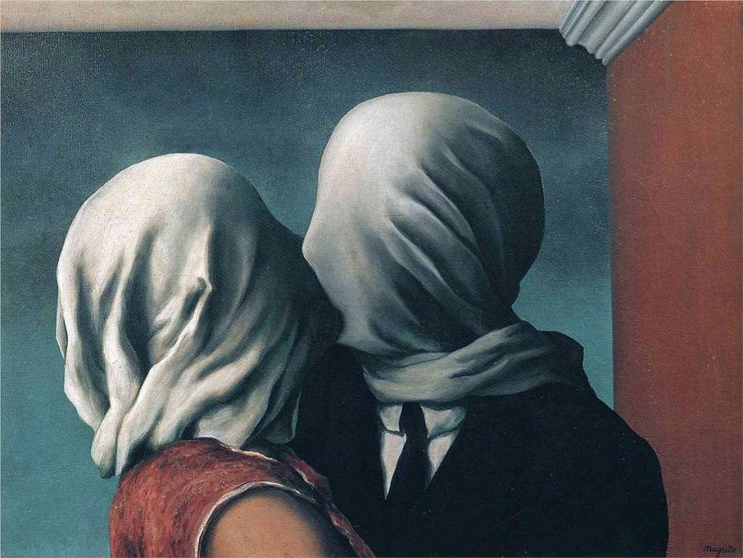
Magritte, 1928, “The Lovers”, oil paint

Rubric: 8th Grade Personified Portraits
Name: ___________________ Date: _________________ Class Code: _______________
Create a gestural portrait-drawing that places emphasis on an object.
Project Criteria | 5 | 4 | 3 | 2 | 1
Student used correct body proportions | Body is 8 heads in length. None of the body parts are shortened or too long. | Body is 8 heads in length, but a few parts are too long or too short. | Body is 7 heads in length, and parts are too long or too short. | Body is 5 or in length, and parts are too long or too short. | Body is 4 or less heads in length, and pars are too long or too short.
Student displayed good craftsmanship | Work fills the entire page. There are 6 values used with the charcoal. | Work fills most of the page. There are 5 used with the charcoal. | Work fills half of the page. There are 3 values used with the charcoal. | Work fills less than half of the page. There are 2 values used with the charcoal. | Work fills less than a quarter of the page. There is only 1 kind of value used with the charcoal.
Student completed an artist’s statement | One paragraph is written. Student did not stray from the writing prompt. Paper is edited very well; there are no grammar/spelling errors. | One paragraph is written. Student did not stray from the writing prompt. Paper is edited well; there are only a few errors. | One paragraph is written. Student strayed from the writing prompt. There are several grammar/spelling errors. | Less than one paragraph (2-3 sentences) is written. Student strayed from the writing prompt. There are at least 7 grammar/spelling errors. | Less than one paragraph (2-3 sentences) is written. Student strayed from the writing prompt. There are at least 10 grammar/spelling errors.
Student demonstrated good effort: took time to develop idea & complete project? (Didn’t rush.) Good use of class time? | The drawing is very well developed. All of the page is filled. Student went beyond the prompt, and clearly experimented. | The drawing is very well developed. All of the page is filled. Student did what was asked from the prompt. | The drawing is okay. There could have been more detail put in. Most, but not all of the paper was used. Student attempted to do the prompt. | The drawing could use some extra time. Not much of the paper was used. Not every task from the prompt was done. | Student did not utilize every class session. There are not many marks on the page; not much of it is filled. The prompt was not achieved.

Your score: _______________
Teacher’s score: _____________
Total possible points: ___________
Comments:

